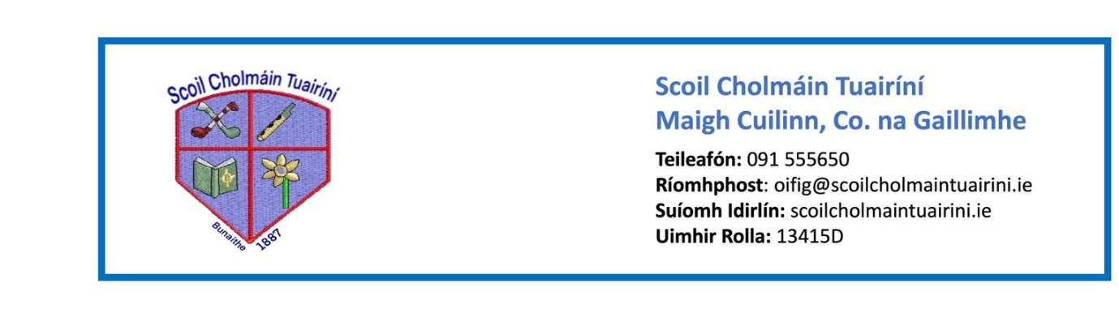 Stáiseanóireacht Naíonáin Shóisearacha 2025/26
- Pencil case with 3 x junior triangular pencils, 3 x erasers,a simple topper, small ruler and twistables (each one labelled with initials). It is better if the pencil case has two compartments, one for pencils and one for colours
- 4 x Whiteboard markers
- 3 x large glue sticks (bring in and leave in school – label with initials)
- 2 x A4 plush mesh storage wallets with zip
- 1 x A3 mesh wallet to store large art pages
- 3 x Medium-sized play doh (unscented)
- Packets of tissues for nose wiping and sneezing
- Headphones (wired)

Reminder
Naíonáin Bheaga will have a shortened day for the first two weeks of school and will finish at 12pm from 28/08/25 – 12/09/25.
Normal pick up time of 1:40pm will begin from Monday, September 15th.

